Hyperarea

Definition
# Source: AI Source: Provided by: [Data Path: Persons Table -> ID Column: 1, Name_En Column: Motasem Essam] -> From: [ChatGPT] on [7/20/2026]
Hyperarea is a generalization of area to higher-dimensional geometry. While ordinary area measures a two-dimensional region, hyperarea measures the $\left(n-1\right)$-dimensional "surface" or boundary measure of an $n$-dimensional object.
In simple terms:
Hyperarea extends the concept of area beyond ordinary 2D geometry to higher-dimensional spaces.
$$\boxed{\text{Hyperarea}=\text{Measure of a Higher-Dimensional Surface}}$$
For an $n$-dimensional object:
$$\boxed{\text{Hyperarea}\text{ has dimension }L^{,n-1}}$$

Relationship to Other Geometric Measurements
# Source: AI Source: Provided by: [Data Path: Persons Table -> ID Column: 1, Name_En Column: Motasem Essam] -> From: [ChatGPT] on [7/20/2026]
A useful dimensional hierarchy is:
$$\boxed{\begin{aligned}Length→L \\ Area→L^{2} \\ Volume→L^{3} \\ Hyperarea→L^{n-1}\end{aligned}}$$
For example:
- A 2D object's measure is area.
- A 3D object's boundary measure is surface area.
- A 4D object's boundary measure is commonly called hyperarea.
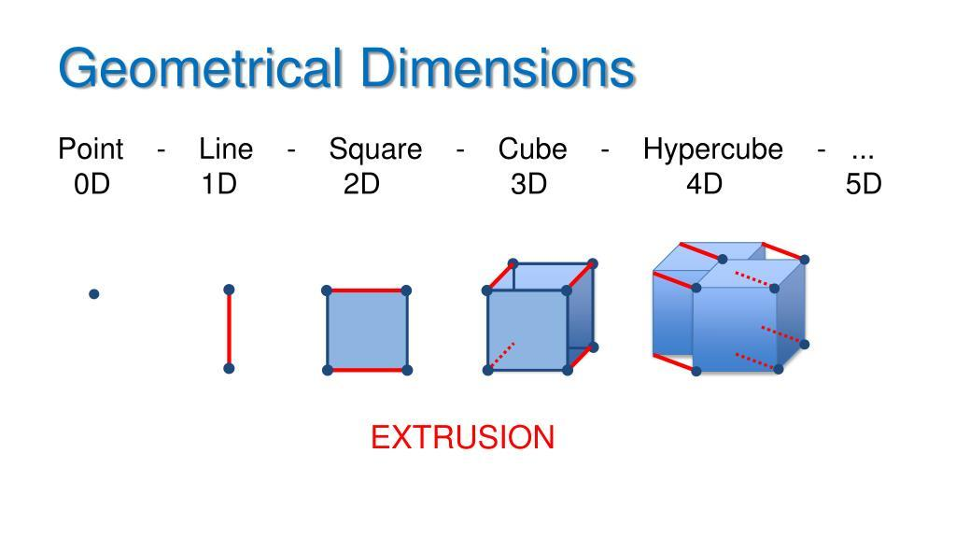
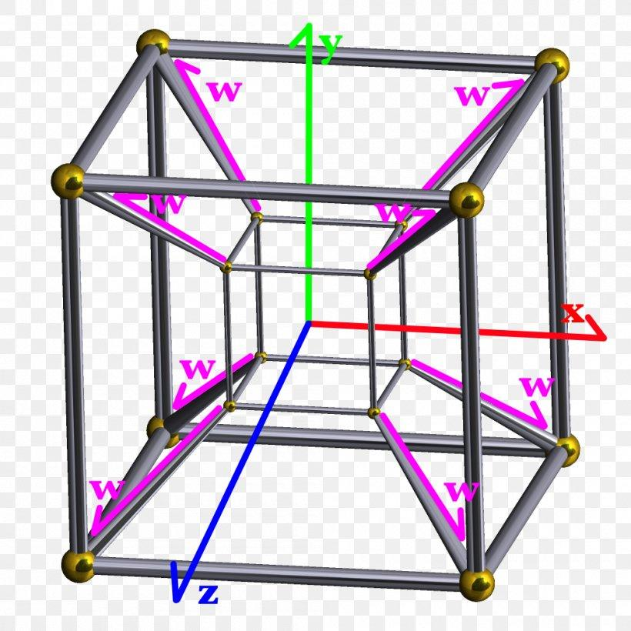
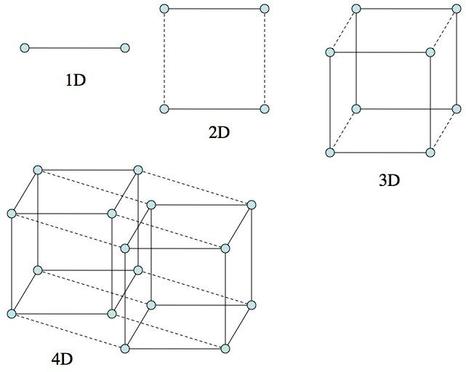
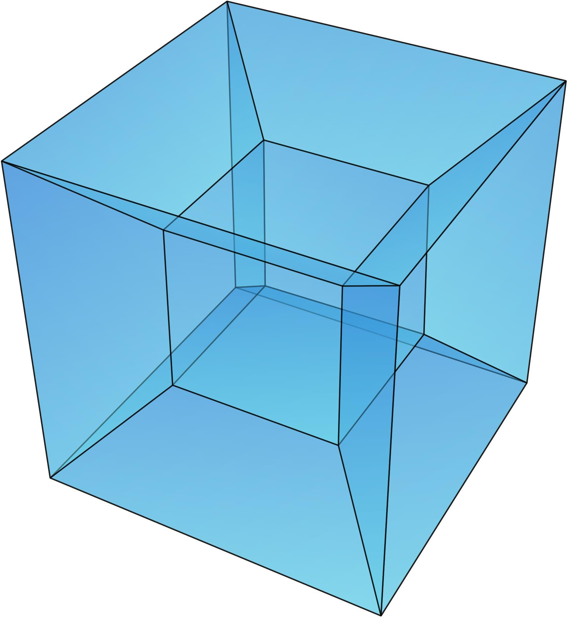

Hyperarea of a Hypercube
# Source: AI Source: Provided by: [Data Path: Persons Table -> ID Column: 1, Name_En Column: Motasem Essam] -> From: [ChatGPT] on [7/20/2026]
For a hypercube with side length $s$ in $n$ dimensions, its hyperarea is:
$$\boxed{H_{n}=2n s^{,n-1}}$$
For example, for a 4-dimensional hypercube (tesseract):
$$\boxed{H_{4}=8s^{3}}$$
This is analogous to the surface area of a 3D cube:
$$SA=6s^{2}$$

Hyperarea vs. Area
# Source: AI Source: Provided by: [Data Path: Persons Table -> ID Column: 1, Name_En Column: Motasem Essam] -> From: [ChatGPT] on [7/20/2026]
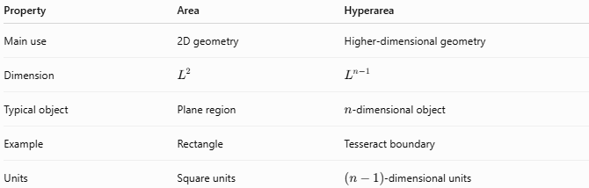
Property | Area | Hyperarea
Main use | 2D geometry | Higher-dimensional geometry
Dimension | $$L^{2}$$ | $$L^{n-1}$$
Typical object | Plane region | $n$-dimensional object
Example | Rectangle | Tesseract boundary
Units | Square units | $\left(n-1\right)$-dimensional units

Hyperarea vs. Volume
# Source: AI Source: Provided by: [Data Path: Persons Table -> ID Column: 1, Name_En Column: Motasem Essam] -> From: [ChatGPT] on [7/20/2026]
Volume measures the interior of a solid, whereas hyperarea generally measures its boundary in higher-dimensional geometry.
For an $n$-dimensional object:
$$\boxed{\text{Hypervolume}∼L^{n}}$$
while:
$$\boxed{\text{Hyperarea}∼L^{n-1}}$$
For a 4D object:
$$\text{Hypervolume}∼L^{4}$$
and:
$$\text{Hyperarea}∼L^{3}$$

Applications
# Source: AI Source: Provided by: [Data Path: Persons Table -> ID Column: 1, Name_En Column: Motasem Essam] -> From: [ChatGPT] on [7/20/2026]
Hyperarea is important in:
- Higher-Dimensional Geometry
- Differential Geometry
- Multivariable Calculus
- Mathematical Analysis
- Topology
- Geometric Measure Theory
- Theoretical Physics
- Computational Geometry
- Computer Graphics
- Mathematical Modeling
- Higher-Dimensional Data Analysis

Advantages
# Source: AI Source: Provided by: [Data Path: Persons Table -> ID Column: 1, Name_En Column: Motasem Essam] -> From: [ChatGPT] on [7/20/2026]
Understanding hyperarea helps to:
- Extend area and surface-area concepts to higher dimensions.
- Describe boundaries of higher-dimensional objects.
- Support higher-dimensional geometric calculations.
- Provide a connection between geometry and calculus.
- Support mathematical modeling of multidimensional spaces.
- Help analyze hypersurfaces and higher-dimensional structures.

Limitations
# Source: AI Source: Provided by: [Data Path: Persons Table -> ID Column: 1, Name_En Column: Motasem Essam] -> From: [ChatGPT] on [7/20/2026]
Hyperarea:
- Is mainly a higher-dimensional mathematical concept.
- Is difficult to visualize directly beyond three dimensions.
- Requires an understanding of higher-dimensional geometry.
- May have different terminology depending on the mathematical context.
- Is not commonly used for ordinary elementary geometry.
- Requires the dimension of the object to be specified.

Key Points
# Source: AI Source: Provided by: [Data Path: Persons Table -> ID Column: 1, Name_En Column: Motasem Essam] -> From: [ChatGPT] on [7/20/2026]
$$\boxed{\text{Hyperarea}=\text{Higher-Dimensional Boundary Measure}}$$
Hyperarea:
- Generalizes the concept of area.
- Extends naturally to higher-dimensional geometry.
- Has dimensional form $L^{n-1}$ for an $n$-dimensional object.
- Is closely related to surface area in three dimensions.
- Is especially relevant to hypersurfaces and higher-dimensional objects.

Conclusion
# Source: AI Source: Provided by: [Data Path: Persons Table -> ID Column: 1, Name_En Column: Motasem Essam] -> From: [ChatGPT] on [7/20/2026]
Hyperarea is a higher-dimensional generalization of area and surface area. It measures the $\left(n-1\right)$-dimensional boundary of an $n$-dimensional object. In ordinary geometry, area and surface area are usually sufficient, but hyperarea becomes useful when studying four-dimensional and higher-dimensional geometry, differential geometry, geometric measure theory, and theoretical mathematics.
$$\boxed{\text{Length}→\text{Area}→\text{Surface Area}→\text{Hyperarea}}$$

